10/06/2017

PMSES Oracle Setup Instructions

After Oracle has been installed (by Josh), and the database base been installed, set up connections in RazorSQL.

Use these same parameters later in Cold Fusion when setting up datasources: pmsescb and filestorage.

On DONPORT 4, in RazorSQL, set up a connection. Password is pmsescb. The SID is pmsesprd, as shown in the URL.

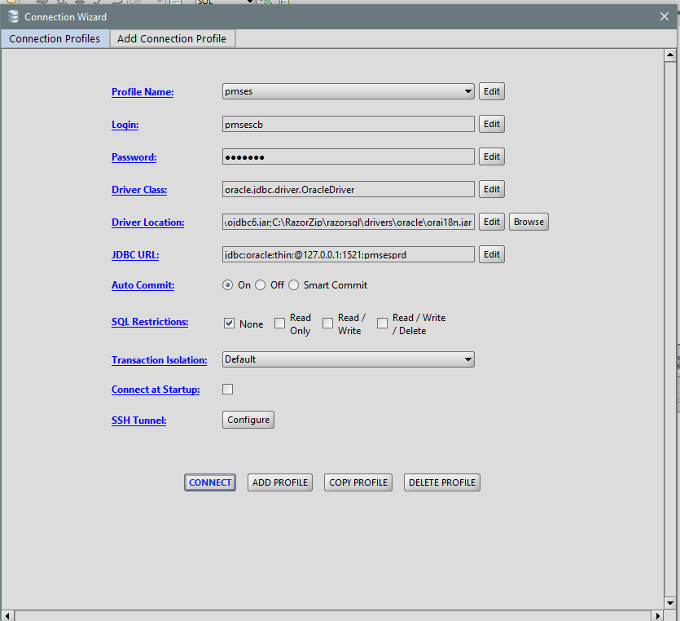

Here is filestorage. Password is filestorage.

